Christopher King
2018141521058
Mechanical Design 1
Class Section 01
12/12/2020

Problem 1
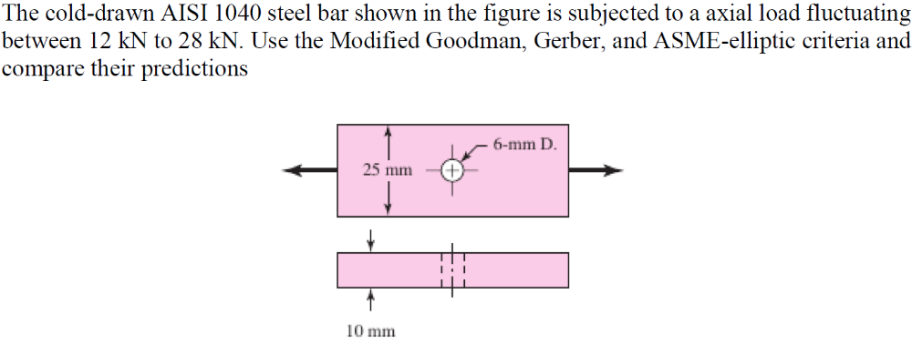
Solution:
For this question, we are asked to use the Modified Goodman, Gerber, and ASME-elliptic criteria and compare their predictions.
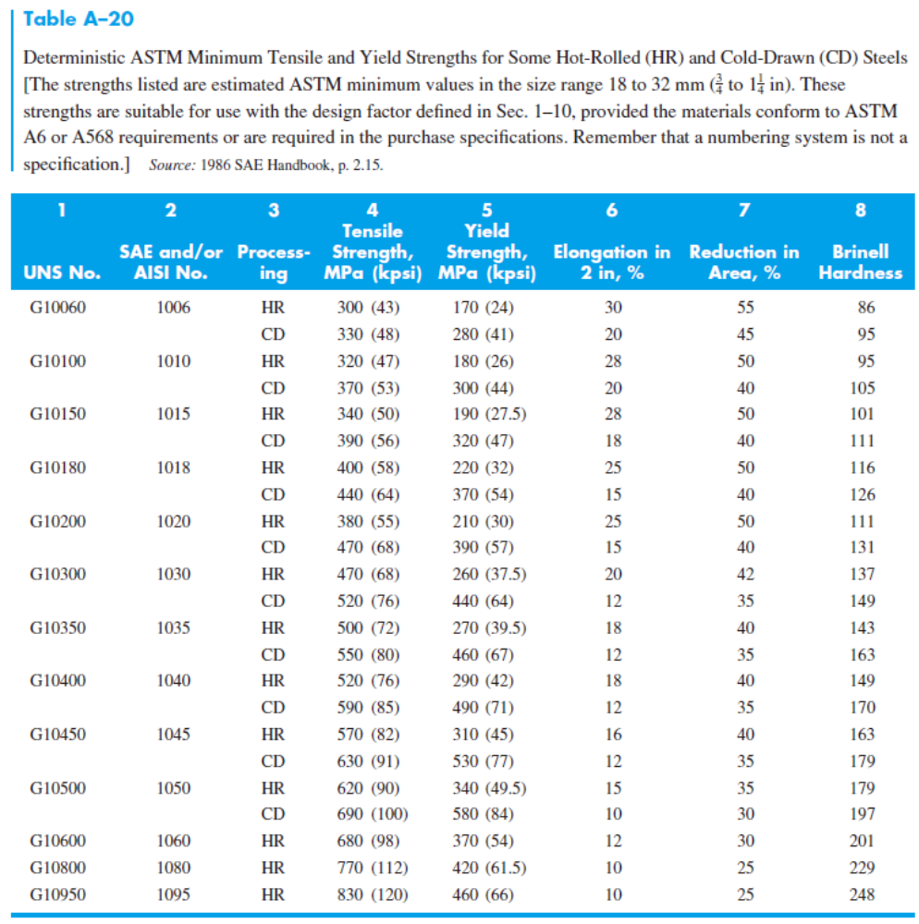
$$S_{ut}=590 MPa=85 kpsi$$
$$S_{y}=490 MPa$$
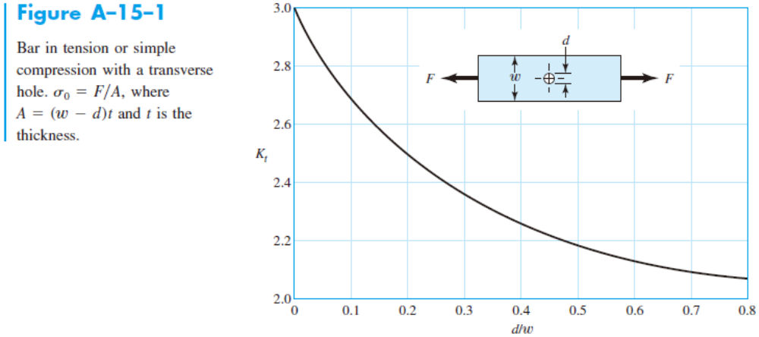
$$\frac{d}{w}=\frac{6 mm}{25 mm}=0.24$$
$$⇒K_{t}=2.44$$
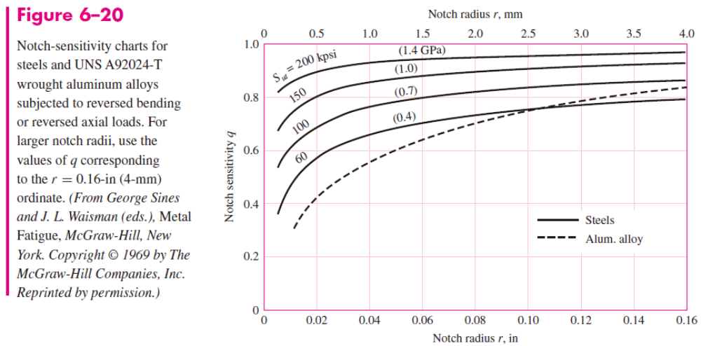
Figure 6-20:
$$q=0.83$$
$$K_{f}=1+q\left(K_{t}-1\right)=1+\left(0.83\right)×\left(2.44-1\right)=2.1952$$
$$σ_{max}=\frac{F_{max}}{A}=\frac{\left(28 kN\right)}{\left(10 mm\right)×\left[\left(25 mm\right)-\left(6 mm\right)\right]}=147.37 MPa$$
$$σ_{min}=\frac{F_{min}}{A}=\frac{\left(12 kN\right)}{\left(10 mm\right)×\left[\left(25 mm\right)-\left(6 mm\right)\right]}=63.16 MPa$$
$$n_{y}=\frac{S_{y}}{σ_{max}}=3.32$$
$$σ_{m}=K_{f}\frac{σ_{max}+σ_{min}}{2}=231.07 MPa$$
$$σ_{a}=K_{f}\left|\frac{σ_{max}-σ_{min}}{2}\right|=92.42 MPa$$
$$S_{e}^{'}=0.5S_{ut}=0.5×\left(590 MPa\right)=295 MPa$$
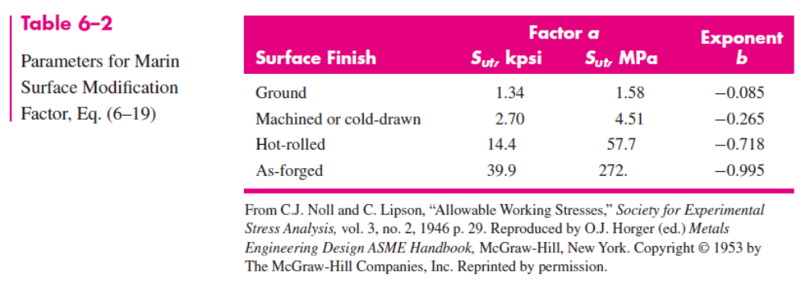
And from the question and Table 6-2, I can know that
$$k_{a}=aS_{ut}^{b}=4.51×{\left(590 MPa\right)}^{-0.265}=0.832$$
$$k_{b}=1$$
$$k_{c}=0.85$$
Therefore,
$$S_{e}=k_{a}k_{b}k_{c}S_{e}^{'}=\left(0.832\right)×\left(1\right)×\left(0.85\right)×\left(295 MPa\right)=208.5 MPa$$
Using Modified Goodman criteria:
$$S_{m}=\frac{\left(S_{y}-S_{e}\right)S_{ut}}{S_{ut}-S_{e}}=\frac{\left[\left(490 MPa\right)-\left(208.5 MPa\right)\right]×\left(590 MPa\right)}{\left[\left(590 MPa\right)-\left(208.5 MPa\right)\right]}=435.35 MPa$$
$$S_{a}=S_{y}-S_{m}=\left[\left(490 MPa\right)-\left(435.35 MPa\right)\right]=54.65 MPa$$
$$r_{crit}=\frac{S_{a}}{S_{m}}=\frac{54.65 MPa}{435.35 MPa}=0.126$$
For this situation,
$$\frac{S_{a}}{S_{m}}=\frac{92.42 MPa}{231.07 MPa}=0.4$$
Therefore,
$$\frac{S_{a}}{S_{e}}+\frac{S_{m}}{S_{ut}}=\frac{1}{n}$$
$$\frac{\left(92.42 MPa\right)}{\left(208.5 MPa\right)}+\frac{\left(231.07 MPa\right)}{\left(590 MPa\right)}=\frac{1}{n}$$
$$⇒n=1.20$$
Using Gerber – Langer criteria:
$$S_{m}=\frac{S_{ut}^{2}}{2S_{e}}\left[1-\sqrt{1+{\left(\frac{2S_{e}}{S_{ut}}\right)}^{2}\left(1-\frac{S_{y}}{S_{e}}\right)}\right]=\frac{{\left(590 MPa\right)}^{2}}{2×\left(208.5 MPa\right)}\left\{1-\sqrt{1+{\left[\frac{2×\left(208.5 MPa\right)}{\left(590 MPa\right)}\right]}^{2}\left[1-\frac{\left(490 MPa\right)}{\left(208.5 MPa\right)}\right]}\right\}=358.46 MPa$$
$$S_{a}=S_{y}-S_{m}=\left[\left(490 MPa\right)-\left(358.46 MPa\right)\right]=131.53 MPa$$
$$r_{crit}=\frac{S_{a}}{S_{m}}=\frac{131.53 MPa}{358.46 MPa}=0.367$$
For this situation,
$$\frac{S_{a}}{S_{m}}=\frac{92.42 MPa}{231.07 MPa}=0.4$$
Therefore,
$$n_{f}=\frac{1}{2}{\left(\frac{S_{ut}}{σ_{m}}\right)}^{2}\frac{σ_{a}}{S_{e}}\left[-1+\sqrt{1+{\left(\frac{2σ_{m}S_{e}}{S_{ut}σ_{a}}\right)}^{2}}\right]==\frac{1}{2}×{\left[\frac{\left(590 MPa\right)}{\left(231.07 MPa\right)}\right]}^{2}×\frac{\left(92.42 MPa\right)}{\left(208.5 MPa\right)}×\left\{-1+\sqrt{1+{\left[\frac{2×\left(231.07 MPa\right)×\left(208.5 MPa\right)}{\left(590 MPa\right)×\left(92.42 MPa\right)}\right]}^{2}}\right\}=1.49$$
Using ASME-elliptic-Langer criteria:
$$n_{f}=\sqrt{\frac{1}{{\left(\frac{σ_{a}}{S_{e}}\right)}^{2}+{\left(\frac{σ_{m}}{S_{y}}\right)}^{2}}}=\sqrt{\frac{1}{{\left[\frac{\left(92.42 MPa\right)}{\left(208.5 MPa\right)}\right]}^{2}+{\left[\frac{\left(231.07 MPa\right)}{\left(490 MPa\right)}\right]}^{2}}}=1.54$$
Comparison:
- The mean stress that is about half of the yield strength.
- The Modified Goodman predict failure larger than the other two.

Problem 2
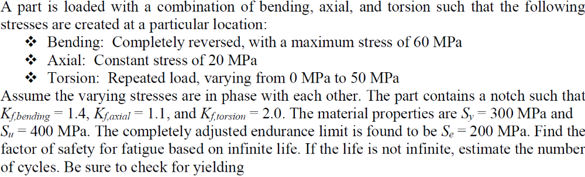
Solution:
For this question, we are asked to find the factor of safety for fatigue based on infinite life. If the life is not infinite, estimate the number of cycles. Be sure to check for yielding.
For bending,
$$σ_{m}=0$$
$$σ_{a}=60 MPa$$
For axial:
$$σ_{m}=20 MPa$$
$$σ_{a}=0$$
For torsion:
$$σ_{m}=25 MPa$$
$$σ_{a}=25 MPa$$
Therefore, considering that the bending, torsional, and axial stresses have alternating and midrange components, the von Mises stresses for the two stress elements can be written as
$$σ_{a}^{'}={\left\{{\left[{\left(K_{f}\right)}_{bending}{\left(σ_{a}\right)}_{bending}+{\left(K_{f}\right)}_{axial}\frac{{\left(σ_{a}\right)}_{axial}}{0.85}\right]}^{2}+3{\left[{\left(K_{fs}\right)}_{torsion}{\left(τ_{a}\right)}_{torsion}\right]}^{2}\right\}}^{\frac{1}{2}}={\left\{{\left[\left(1.4\right)×\left(60 MPa\right)+\left(1.1\right)×\frac{\left(0 MPa\right)}{0.85}\right]}^{2}+3×{\left[\left(2\right)×\left(25 MPa\right)\right]}^{2}\right\}}^{\frac{1}{2}}=120.6 MPa$$
$$σ_{m}^{'}={\left\{{\left[{\left(K_{f}\right)}_{bending}{\left(σ_{m}\right)}_{bending}+{\left(K_{f}\right)}_{axial}{\left(σ_{m}\right)}_{axial}\right]}^{2}+3{\left[{\left(K_{fs}\right)}_{torsion}{\left(τ_{m}\right)}_{torsion}\right]}^{2}\right\}}^{\frac{1}{2}}={\left\{{\left[\left(1.4\right)×\left(0 MPa\right)+\left(1.1\right)×\frac{\left(20 MPa\right)}{0.85}\right]}^{2}+3×{\left[\left(2\right)×\left(25 MPa\right)\right]}^{2}\right\}}^{\frac{1}{2}}=89.35 MPa$$
Using Modified Goodman criteria:
Therefore,
$$\frac{S_{a}^{'}}{S_{e}}+\frac{S_{m}^{'}}{S_{ut}}=\frac{1}{n}$$
$$\frac{\left(120.6 MPa\right)}{\left(200 MPa\right)}+\frac{\left(89.35 MPa\right)}{\left(400 MPa\right)}=\frac{1}{n}$$
$$⇒n=1.21$$
Check
$$n_{y}=\frac{S_{y}}{σ_{max}}=\frac{S_{y}}{σ_{a}^{'}+σ_{m}^{'}}=\frac{\left(300 MPa\right)}{\left(120.6 MPa\right)+\left(89.35 MPa\right)}=1.43$$

